Srinivas University
Mangalore ‐ India
Atomic Research Centre
Centre for Mudra loan & MSMEs
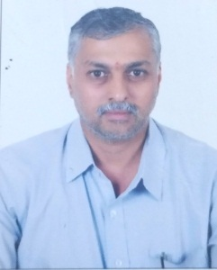
Dr Mahesh K M
Post-Doctoral Research Fellow
Srinivas University

1. Purpose of ARC: Mudra loan provides working capital to MSMEs and Micro entrepreneurs to access credit from the formal financial system,90% of the MSME sector comprises Micro enterprises, Small industries, artisans, rural and urban areas to access credit and contribution to economic growth.

2. Objective of ARC :
- To encourage entrepreneurs and small business units to expand their capabilities and operations.
- To reduce over-indebtedness
- To provide a formal system of credit /finance
- Funding based on stages of growth through Shishu, Kishor and Tarun
- Businesses linked agriculture, MSMEs and self-Employed Small business will be the focus areas of Mudra Bank.

3. Description of Proposed Research :
We working out the Impact of MUDRA loan in Financial Inclusion, Sustainable development, Business expansion, Employment generation, Quality life of the entrepreneurs, GDP Growth and financial beneficiaries (Member of Leading Institutions).
4. Expected Outcome :
- To Analysis the contribution of MSME to the economic growth
- To aspiring entrepreneurs to access finance from the formal financial Institutions
- Funds for technology and innovations
- Impact of MUDRA on food processing MSMEs
- Social, economic and financial empowerment of women.

5. List of the Team Members :
Dr P.S Aithal, Vice-Chancellor, Srinivas University
Dr Mahesh K.M, Post-Doctoral Research Fellow

6. List of Working Papers :
(1) A Study on the Impact of Schemes and programmers of Government of India on agriculture to increase Productivity, Profitability, Financial Inclusion and welfare of Farmers to transform them into Modern Society.
(2) Impact of Sustainable Finance on MSMEs and Company: To promote green growth and Sustainable development.
(3) Government of India development Mechanisms for Micro, Small and Medium Enterprises including Retail and wholesale MSMEs: The engines of Socio-Economic growth.

7. List of related Published Papers in Journals, Proceedings, Book Chapters, Magazines by this Group.
(1)
(2)
(3)

Dr Mahesh K.M

